Disease epidemics and species interactions: a manipulation of seasonal establishment of fungal diseases in an old field

Authors: Rita L. Grunberg^{1,2*}, Fletcher W. Halliday^{1,3}, Kayleigh R. O’Keeffe^{1,4,} Brooklynn N. Joyner^{1,5}, Robert W. Heckman^{1,6,7}, and Charles E. Mitchell^{1,8}
Author Affiliations:
¹Department of Biology, University of North Carolina, Chapel Hill, NC USA
²Current affiliation: Wilson Center for Science and Justice, Duke University, Durham, NC 27708
³Current affiliation: Department of Botany and Plant Pathology, Oregon State University, Corvallis, OR, USA
⁴ Current affiliation: Department of Biological Sciences, Lehigh University, Bethlehem, PA USA
⁵ Current affiliation: Department of Parks, Recreation & Tourism Management, North Carolina State University, NC USA
⁶ Department of Integrative Biology, University of Texas at Austin, Austin, TX USA
⁷Current affiliation: US Department of Agriculture Forest Service, Rocky Mountain Research Station, Cedar City, UT USA
⁸ Environment, Ecology and Energy Program, University of North Carolina, Chapel Hill, NC, US

Corresponding Author: Rita Grunberg, rita.grunberg@law.duke.edu

Class I. Data Set Descriptors
I.A. Data set identity: Disease epidemics and species interactions: a manipulation of seasonal establishment of fungal diseases in an old field
I.B. Data set identification codes:
Data S1.zip (includes 8 .csv files)
- monthly_disease_survey_171819.csv
- plot_treatments.csv
- endophyte_prevalence_2019.csv
- plot_biomass_171819.csv
- plot_biomass_sorted_2018.csv
- plant_community_data.csv
- longitudinal_disease_survey_2017.csv
- longitudinal_disease_survey_2018.csv

Metadata S1 (this file)
I.C. Data set description
I.C.1 Originators:
Dr. Fletcher W. Halliday, Dr. Kayleigh R. O’Keeffe, and Dr. Charles E. Mitchell
I.C.2 Abstract:
Many disease epidemics recur seasonally, and such seasonal epidemics can be shaped by species interactions among parasites, pathogens, or other microbes. To understand the consequences of species interactions and their timing, field experiments are a classic approach, yet little applied in seasonal epidemics. Our research objective was to help fill this gap by manipulating the seasonal timing of establishment of infectious diseases while tracking epidemics and other ecological responses. To do this, we conducted a multi-year field experiment in an old field in the Piedmont of North Carolina, USA dominated by the grass species tall fescue (Festuca arundinacea Schreb.). Tall fescue experienced seasonal epidemics of multiple foliar fungal diseases: anthracnose in spring, brown patch in mid-summer, and crown rust in late summer to fall. In a fully randomized design with four treatments, we applied fungicide to replicate plots of intact vegetation in specific seasons. One treatment was designed to delay the establishment of anthracnose until mid-summer, and another to delay the establishment of both anthracnose and brown patch until fall. In a third treatment, fungicide was applied year-round and, in a fourth treatment, fungicide was never applied. The experiment comprised 64 plots, each 2-m × 2-m, from May 2017 through February 2020. We here report a dataset documenting responses in community assembly of both plants and foliar fungi. To track disease prevalence in the host population across seasons and years, this dataset includes monthly leaf-level observations of the disease status of over 100,000 leaves. To quantify transmission and within-host priority effects, we longitudinally surveyed disease status in host individuals of known age twice weekly for 16 weeks in 2017, and weekly for 21 weeks in 2018, comprising over another 80,000 observations of disease status. Finally, the dataset includes annual data on infection prevalence of the systemic fungal endophyte Epichloë coenophiala, community-level aboveground plant biomass, and plant community relative abundances. These data can be used for meta-analyses, comparisons, and syntheses across systems as ecologists seek both to predict shifts in, and to mechanistically understand, seasonal disease epidemics. We request that users of this dataset cite this paper in all publications resulting from its use.
I.D. Key words:
Durham, North Carolina, Monthly sampling, Multi-year experiment, Disease ecology, Old field, Longitudinal data, Foliar fungal pathogens, Seasonal epidemics, Tall fescue, Priority effects, Community assembly, Rhizoctonia solani, Puccinia coronata

Class II. Research origin descriptors
II.A. Overall project description:
II.A.1 Identity:
A longitudinal dataset of disease prevalences in a population of tall fescue exposed to different fungicide regimes for three years.
II.A.2 Originators:
The original project aims were developed by Fletcher W. Halliday and Charles E. Mitchell. The experiment was designed by Fletcher W. Halliday and Kayleigh R. O’Keeffe. Disease surveys were conducted by Fletcher W. Halliday, Kayleigh R. O’Keeffe, and Brooklynn N. Joyner. Plant community surveys were conducted by Robert W. Heckman. The project was managed by Brooklynn N. Joyner and Charles E. Mitchell. Data management and cleaning were implemented by Brooklynn N. Joyner and Rita L. Grunberg. Visualizations, statistics, and synthesis of research data were conducted by Rita L. Grunberg.
II.A.3 Period of study:
Data collection ranges from May 2017 to February 2020. During this period, we conducted a monthly disease prevalence survey every 30 days, longitudinal disease surveys in 2017 and 2018, and plant community surveys at the end of the growing season in 2017, 2018, and 2019.
II.A.4 Objectives:
The goal of this project was to assess the role of historical contingency in disease epidemics within a population of tall fescue. We manipulated tall fescue’s history of exposure to disease using fungicide treatments that varied in duration throughout the growing season. In addition to disease data, we assayed plant diversity, plant biomass, and the presence of a mutualist endophyte of tall fescue, Epichloë coenophiala, in response to the fungicide treatments. These data provide information on various foliar fungal disease epidemics in tall fescue and their responses to different fungicide treatment regimens over three years. Importantly, we also provide longitudinal infection data on tracked host individuals (i.e., tall fescue tillers) along with population-level disease prevalence.
II.A.5 Abstract:
Many disease epidemics recur seasonally, and such seasonal epidemics can be shaped by species interactions among parasites, pathogens, or other microbes. To understand the consequences of species interactions and their timing, field experiments are a classic approach, yet little applied in seasonal epidemics. Our research objective was to help fill this gap by manipulating the seasonal timing of establishment of infectious diseases while tracking epidemics and other ecological responses. To do this, we conducted a multi-year field experiment in an old field in the Piedmont of North Carolina, USA dominated by the grass species tall fescue (Festuca arundinacea Schreb.). Tall fescue experienced seasonal epidemics of multiple foliar fungal diseases: anthracnose in spring, brown patch in mid-summer, and crown rust in late summer to fall. In a fully randomized design with four treatments, we applied fungicide to replicate plots of intact vegetation in specific seasons. One treatment was designed to delay the establishment of anthracnose until mid-summer, and another to delay the establishment of both anthracnose and brown patch until fall. In a third treatment, fungicide was applied year-round and, in a fourth treatment, fungicide was never applied. The experiment comprised 64 plots, each 2-m × 2-m, from May 2017 through February 2020. We here report a dataset documenting responses in community assembly of both plants and foliar fungi. To track disease prevalence in the host population across seasons and years, this dataset includes monthly leaf-level observations of the disease status of over 100,000 leaves. To quantify transmission and within-host priority effects, we longitudinally surveyed disease status in host individuals of known age twice weekly for 16 weeks in 2017 and weekly for 21 weeks in 2018, comprising over another 80,000 observations of disease status. Finally, the dataset includes annual data on infection prevalence of the systemic fungal endophyte Epichloë coenophiala, community-level aboveground plant biomass, and plant community relative abundances. These data can be used for meta-analyses, comparisons, and syntheses across systems as ecologists seek both to predict shifts in, and to mechanistically understand, seasonal disease epidemics. We request that users of this dataset cite this paper in all publications resulting from its use.
II.A.6 Sources of funding:
This work was supported by the NSF-USDA joint program in Ecology and Evolution of Infectious Diseases (USDA-NIFA AFRI grant 2016-67013-25762). R.Heckman was supported in part by the USDA Forest Service, Rocky Mountain Research Station. The findings and conclusions in this publication are those of the author and should not be construed to represent any official USDA or U.S. Government determination or policy.
II.B. Specific subproject description
II.B.1 Site description
II.B.1.a Site type: Old-field grassland
II.B.1.b Geography: Widener Farm in the Duke Forest Teaching and Research Laboratory in Orange Co., North Carolina, USA (Figure 1). Latitude and longitude of experimental plots: 36 00.5370, -79 01.0841
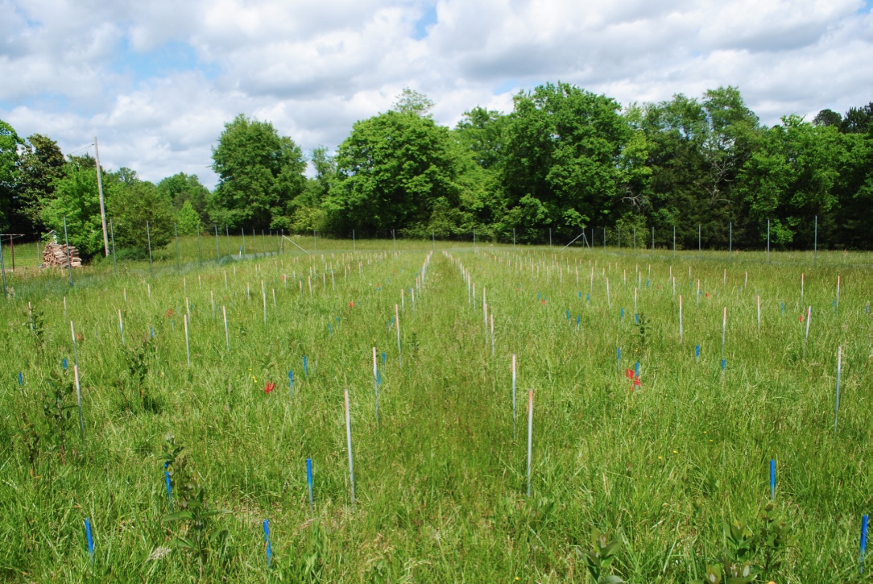
Figure 1. Photograph of the field site with experimental plots established throughout (delineated by the white poles). Plant community surveys were conducted within an established subplot of the plot (delineated by the blue poles). Photograph taken by Brooklynn. N. Joyner.
II.B.1.c Habitat: North Carolina Piedmont Old field grassland dominated by tall fescue and other perennial herbaceous plants.
II.B.1.d Geology, landform: Tilled for row crops from the mid-1950s until 1996.
II.B.1.e Watersheds, hydrology: NA
II.B.1.f Site history: This research site was originally used to grow row crops until 1996 and is now mowed annually in the summer to maintain herbaceous plant dominance.
II.B.1.g Climate: Average of 1,221 mm of annual precipitation. Detailed historic climate data for this site is available through Duke Forest Research and Teaching Lab.
II.B.2 Experimental or sampling design
II.B.2.a. Design characteristics: There are 4 fungicide application treatments that coincide with the start of the focal pathogen epidemics (Table 1, below).
Table 1. Summary of the four treatments, their timing of fungicide exposure, and goal of the treatment.
Treatment | Fungicide exposure | Goal
Control | Never sprayed with fungicide | Ambient disease; expose populations to anthracnose first
7-month | January – July, the beginning of the brown patch epidemic | Expose the host population to anthracnose and brown patch simultaneously
9- month | January –September, the beginning of the crown rust epidemic | Expose the host populations to anthracnose, brown patch, and crown rust simultaneously
Always sprayed | Year-round spraying of fungicide | Exclude disease from population

In total, there are 64 plots and each treatment is replicated in 16 plots; fungicide treatments were randomly assigned to plots (i.e., no spatial blocking). These fungicide treatments were designed to manipulate the order of arrival of three foliar fungal parasites using a topical fungicide application that excluded pathogens from a plot until specific epidemics began (Table 1); this occurs roughly at two points in time – first, during July when both anthracnose and brown patch epidemics are occurring, and second, during September when crown rust epidemics start and all three pathogen epidemics overlap in the host population. The time for ceasing fungicide application in a treatment to manipulate exposure was based on data from Halliday et al. (2017).
DISEASE DATA: From this experiment, we collected various types of infection data: (1) monthly prevalence surveys for all plots, (2) additional mid-monthly surveys for the control plots in 2017, and (3) longitudinal surveys on tracked plants. These data types are described below.
- PREVALENCE DATA, ALL TREATMENTS: Approximately every 30 days a prevalence survey was conducted in all 64 plots of the experiment. Within each plot, 20 random resident tillers (i.e., individual grass shoots) were visually inspected for disease symptoms. Data range from May 2017 to February 2020. There is no December 2017 prevalence survey.
- PREVALENCE DATA, ONLY CONTROL (NO FUNGICIDE-TREATED PLOTS): In the fall of 2019, three “mid-monthly” surveys were conducted at a smaller scale to get a better resolution of ongoing pathogen epidemics. Our aim was to document a more precise arrival of brown patch and crown rust. Every ~15 days we conducted an additional prevalence survey of 10 random plants from the control plots. These mid-monthly surveys were conducted in August, October, and November 2019.
- LONGITUDINAL DATA: In 2017, Sentinel outplants were deployed into resident vegetation throughout the plots for surveying on a weekly basis. They were deployed in 3 waves, or cohorts, to coincide with the arrival of the Rhizoctonia and Puccinia epidemics following Halliday et al. (2017). One tiller on each outplant was surveyed weekly for fungal and herbivory damage; every leaf on the tiller was surveyed until the leaf naturally senesced. Thus, we have longitudinal infection data for each leaf on a marked tiller. Surveys began in July 2017 and ended 1 November 2017. After the last survey, the tiller of the plant was collected to be tested for Epichloë coenophiala presence and the aboveground biomass was collected. The seed source of the outplants was Rebecca McCulley (received in May 2017).
ENDOPHYTE DATA: Along with disease prevalence data, we collected data on the prevalence of the mutualistic, vertically transmitted, systemic fungal endophyte, Epichloë coenophiala, in 2019. Ten tillers were collected from each of the 64 plots; the proportion of tillers that tested positive for Epichloë was used to determine prevalence.
PLANT COMMUNITY DATA: Towards the end of each growing season (October or November), we conducted plant community surveys in each plot. The cover of all plant species plus litter and bare ground was visually estimated within a 0.75-m × 0.75-m permanent quadrat in each plot. Plant community surveys were conducted on 09 November 2017, 10 October 2018, and 10 October 2019 by R. Heckman.
PLANT BIOMASS DATA: At the end of the growing season, total above-ground biomass was collected from each plot. Methodology for obtaining biomass samples differed each year (see section 3.a).
II.B.2.b. Permanent plots: There are 64 plots arranged in a 4 × 16 array. These plots are 2-m × 2-m and each plot is separated by 1 m with a 2-m mowed buffer surrounding the entire experimental area (Figure 2, below).
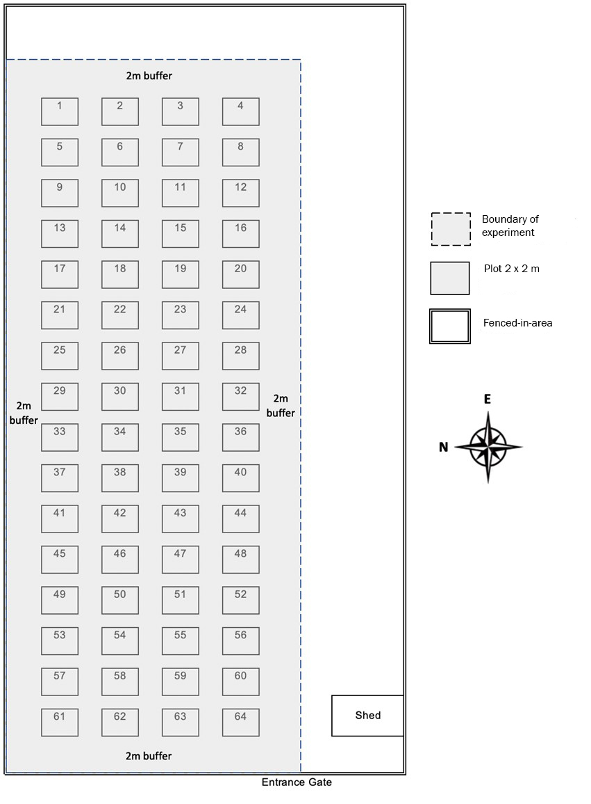
Figure 2. Map of the 64 experimental plots and their spatial arrangement. Plots are labeled 1–64, which correspond to their plot ID in data files.
II.B.2.c. Data collection period, frequency, etc.: The frequency of data collection varied per each aim of the project (described above in section 3.a). The core dataset consists of a monthly disease survey for three years.
II. B.3 Research methods
II.B.3.a Field/laboratory:
For disease surveys (i.e., Disease Data in section 2.a), disease symptoms were visually assessed on each living leaf within a tiller (i.e., individual grass shoot). A leaf was considered living until 90% of its tissue senesced. Leaves were identified relative to each other, where the outermost leaf (leaf ID = 1) is the oldest and the youngest leaf is the innermost leaf (leaf ID = greatest numeric value) (Figure 3). Beginning with the oldest leaf, we recorded pathogen and herbivory damage present in the living part of the leaf. We did not consider lesions/damages in senesced tissue as “present”, part of severity, or any other data.
Plot-level disease surveys (Prevalence all treatments, Disease Data) included randomly sampling 20 tillers per plot (Figure 4).
- 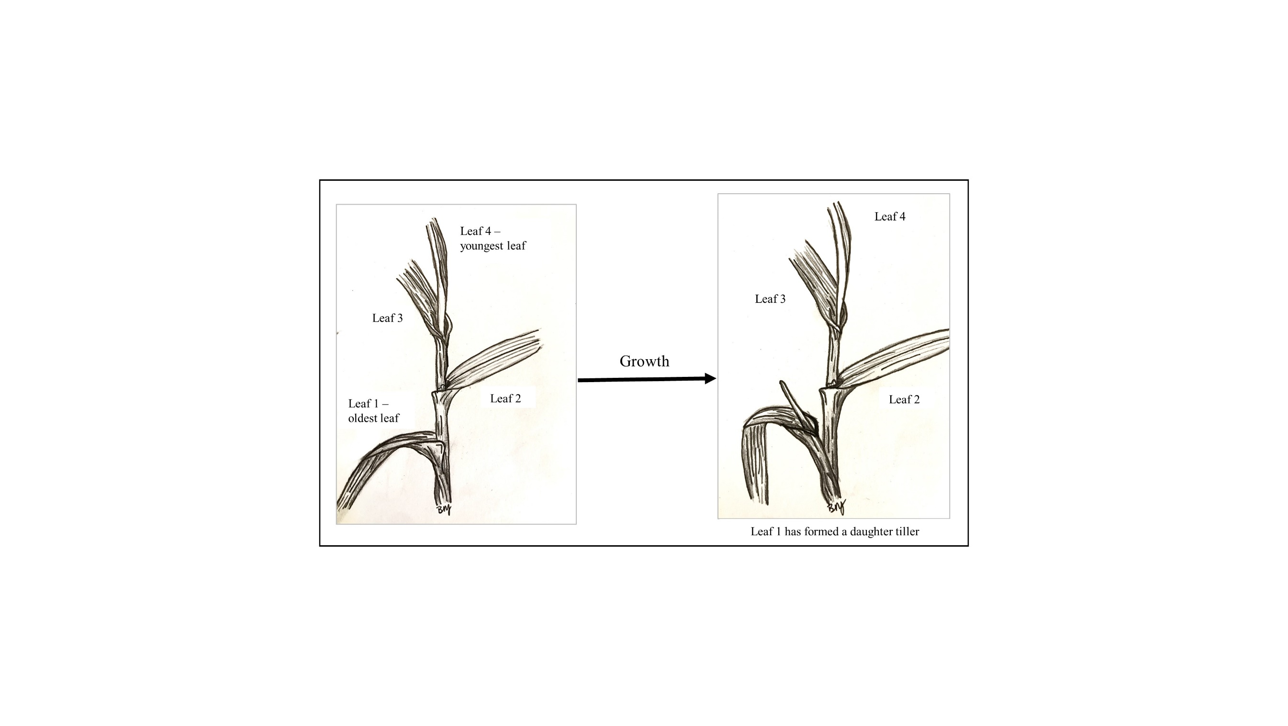
Figure 3. Diagram showing leaf ID within a tiller. The oldest is leaf 1 and the youngest is leaf 4. Drawn by Brooklynn N. Joyner.
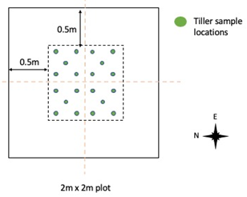
Figure 4. Diagram for systematic random sampling of tillers with experimental plots.
Marked tillers for the interaction data (i.e., Longitudinal, Disease Data) were tagged using a plastic band placed just beneath the oldest living leaf on the tiller – all leaves above the band were living and all leaves below the band were senesced. All leaves on the tiller were surveyed as per the monthly disease surveys. If the tiller died, we recorded the cause of death (disease, rodent, drought) and selected a new tiller to survey. For resident tillers selected in plots (2018 data), we located an existing tiller that is closest in proximity, in any direction, to the tiller that died. We removed the band from the dead tiller and placed it below the oldest living leaf on the new tiller. A new Tiller ID was assigned. For outplants growing in pots (2017 data), we randomly picked another tiller in the pot for tracking, here we removed the plastic ID band from the dead tiller and placed it below the oldest living leaf on the new tiller. Because the fescue plant was in a pot, we knew that all the tillers were from the same individual, so we assigned a new tiller ID, but not a new plant ID.
Epichloë coenophiala infection status (i.e., Endophyte data in section 2.a) was assayed using an immunoblot assay (Agrinostics Ltd. Co, Watkinsville, GA, USA) following directions by the manufacturer. To assess infection, tillers were harvested from the field, put on ice, and stored in -20 °C freezer until processed in the lab. A 1.6 to 3.2-mm-thick cross-section taken from about 3.2 mm from the base of the stored tiller was used in the immunoblot assay.
For the plant community data (Plant community data in section 2.a), we measured the absolute cover of every plant species independently from each other since plants may overlap spatially. Thus, total cover within a plot can exceed 100% in plots.
The method of collecting biomass (Biomass data in section 2.a) differed between years. Specifically, we varied the area of the harvested sample and whether or not biomass was sorted into different functional groups or left unsorted. In 2017, a 0.75-m × 0.75-m (total area 0.5625 m²) subplot was created in the southeast corner of each plot. For estimating biomass, all the vegetation rooted within the subplot was harvested, oven-dried, and weighed together. In 2018, two 0.10-m² rectangular “strips” were harvested for biomass, resulting in a total of 0.20 m² of harvested area per plot. Biomass from each strip was sorted, oven-dried, and weighed as one of the following categories: fescue, non-fescue monocots, woody dicots, non-woody dicots, dead material of any kind. In 2019, two 0.10-m² rectangular strips were harvested for biomass, but their placement was rotated 90° from the 2018 locations. Biomass was harvested, oven-dried, and weighed together. Biomass was not sorted/categorized in 2017 and 2019.
II.B.3.b Instrumentation: N/A
II.B.3.c Taxonomy and systematics: Fungal diseases were identified using Smiley et al. 2005 Compendium of Turfgrass Diseases, Third Edition: https://doi.org/10.1094/9780890546154 References for taxonomic keys, identification, and location of voucher specimens, etc.
II.B.3.d Permit history: This experiment was approved by Duke Forest under research registration number: R1617-434.
II.B.4 Project personnel: Principal investigators of project: Fletcher Halliday, Kayleigh O’Keeffe, and Charles E. Mitchell. Primary funding source principal investigators: Iganzio Carbone, Corbin Jones, James Umbanhowar, and Charles E. Mitchell; Technicians: Anita Simha, Matthew Carey, Julie Long, Storm Crews, Charles Muirhead, Julia Knorr, Ryan Cook; Supervisors: Brooklynn N. Joyner; Students: Fletcher Halliday, Kayleigh O’Keeffe, Anita Simha, Brandon Wheeler, Jordan Link, Claire Thefaine, Safiyyah Motaib; Postdoctoral researchers: Rita Grunberg, Fletcher Halliday, Robert Heckman; Secondary funding source investigator: Robert Heckman

Class III. Data set status and accessibility
III.A Status
III.A.1 Latest update: Date of last modification of data set
III.A.2 Latest archive date: Date of last data set archival
III.A.3 Metadata status: Date of last metadata update and current status
III.A.4 Data verification: Status of data quality assurance checking
III.B Accessibility
III.B.1 Storage location and medium: Pointers to where data reside (including archival required by the Ecological Society of America (ESA) Open Research policy and redundant archival sites)
III.B.2 Contact person: Dr. Charles E. Mitchell, University of North Carolina Department of Biology, mitchell@bio.unc.edu
III.B.3 Copyright restrictions: None
III.B.4 Proprietary restrictions: Please cite this data-paper when using its data in publications. We request that researchers inform us of how they are using this data.
III.B.5 Costs: None.

Class IV. Data structural descriptors
The data set includes 8 files that are in DataS1.zip. The zip folder contains:
- [monthly_disease_survey_171819.csv] the monthly disease surveys for 2017, 2018, 2019 in the 64 experimental plots
- [plot_treatments.csv] contains information on the plot location and fungicide application
- [endophyte_prevalence_2019.csv] prevalence of the endophyte, Epichloë coenophiala, in 2019
- [plot_biomass_171819.csv] total plot biomass for 2017, 2018, 2019
- [plot_biomass_sorted_2018.csv] plant community biomass in 2018. This includes the sorted biomass data
- [plant_community_data.csv] updated version of the plant species absolute cover data from 64 plots for 2017, 2018, 2019.
- [longitudinal_disease_survey_2017.csv] longitudinal disease data on outplants in 2017
- [longitudinal_disease_survey_2018.csv] longitudinal disease data on resident plants in 2018.

IV.A Data set file
Identity: monthly_disease_survey_171819.csv
Size: 24 columns and 116,693 records, including header row, 7,671 KB.
Format and storage mode: Comma-separated values (.csv)
Header information: See column descriptions in section B.
Alphanumeric attributes: Mixed.
Special characters/fields: Missing information was classified as “NA” in each cell.

Identity: plot_treatments.csv
Size: 4 columns and 65 records, including header row, 2 KB.
Format and storage mode: Comma-separated values (.csv)
Header information: See column descriptions in section B.
Alphanumeric attributes: Mixed.
Special characters/fields: Missing information was classified as “NA” in each cell.

Identity: endophyte_prevalence_2019.csv
Size: 12 columns and 64 records, including header row, 2 KB.
Format and storage mode: Comma-separated values (.csv)
Header information: See column descriptions in section B.
Alphanumeric attributes: Mixed.
Special characters/fields: Missing information was classified as “NA” in each cell.

Identity: plot_biomass_171819.csv
Size: 3 columns and 193 records, including header row, 4 KB.
Format and storage mode: Comma-separated values (.csv)
Header information: See column descriptions in section B.
Alphanumeric attributes: Mixed.
Special characters/fields: Missing information was classified as “NA” in each cell.

Identity: plot_biomass_sorted_2018.csv
Size: 7 columns and 65 records, including header row, 4 KB.
Format and storage mode: Comma-separated values (.csv)
Header information: See column descriptions in section B.
Alphanumeric attributes: Mixed.
Special characters/fields: Missing information was classified as “NA” in each cell.

Identity: plant_community_data.csv
Size: 46 columns and 193 records, including header row, 42 KB.
Format and storage mode: Comma-separated values (.csv)
Header information: See column descriptions in section B.
Alphanumeric attributes: Mixed.
Special characters/fields: Missing information was classified as “NA” in each cell.

Identity: longitudinal_disease_survey_2017.csv
Size: 16 columns and 35,957 records, including header row, 1,719 KB.
Format and storage mode: Comma-separated values (.csv)
Header information: See column descriptions in section B.
Alphanumeric attributes: Mixed.
Special characters/fields: Missing information was classified as “NA” in each cell.

Identity: longitudinal_disease_survey_2018.csv
Size: 22 columns and 46,054 records, including header row, 2,697 KB.
Format and storage mode: Comma-separated values (.csv)
Header information: See column descriptions in section B.
Alphanumeric attributes: Mixed.
Special characters/fields: Missing information was classified as “NA” in each cell.

IV.B Variable information
Table 2. List of column headers and definitions for monthly_disease_survey_171819.csv
Variable identity | Variable definition | Units of measurement
Month | Month of disease survey | month, character
Year | year of disease survey | year, numeric
Plot | unique experimental plot ID, 1-64 | plot, numeric
Fungicide | Duration of fungicide exposure treatments (see table 1 for more info on treatments) | character
Plant | ID of plant surveyed (1-20) | ID, numeric
Leaf | ID of leaf surveyed, 1 is the oldest | ID, numeric
Damage | Describes if there is damage on the leaf, either due to disease or herbivory | D: damaged, ND: no damage, S: senesced between surveys
anthracnose | anthracnose symptoms, caused chiefly by Colletotrichum cereale | presence (1) or absence (0)
crown_rust | crown rust symptoms, caused by Puccinia coronata | presence (1) or absence (0)
brown_patch | brown patch symptoms, caused by Rhizoctonia solani | presence (1) or absence (0)
Smut | leaf smut symptoms | presence (1) or absence (0)
GLS | grey leaf spot symptoms | presence (1) or absence (0)
RRust | red rust symptoms, caused by Puccinia graminis | presence (1) or absence (0)
Sclerotinia | sclerotinia symptoms | presence (1) or absence (0)
TML | Symptoms of an unknown fungal pathogen, with symptoms similar to Septoria sp. symptoms | presence (1) or absence (0)
Chew | evidence of chewing | presence (1) or absence (0)
Beetle | Beetle herbivory | presence (1) or absence (0)
Mollusk | Mollusk herbivory | presence (1) or absence (0)
Mining | leaf mining | presence (1) or absence (0)
Mech | mechanical damage | presence (1) or absence (0)
Chlo | presence of chlorosis | presence (1) or absence (0)
Mow | mowing damage | presence (1) or absence (0)
Date.collected | date of survey | month-date-year

Table 3. List of column headers and definitions for plot_treatments.csv
Variable identity | Variable definition | Units of measurement
Plot | unique experimental plot ID, 1-64 | plot, numeric
row | row ID within the experimental area | row, numeric
column | column ID within the experimental area | column, numeric
Fungicide | duration of fungicide exposure | treatment, character

Table 4. List of column headers and definitions for epichloe_prevalence.csv
Variable identity | Variable definition | Units of measurement
Plot | unique experimental plot ID, 1-64 | plot, numeric
Tiller_A | Tiller A Epichloë infection status | presence (1) or absence (0)
Tiller_B | Tiller B Epichloë infection status | presence (1) or absence (0)
Tiller_C | Tiller C Epichloë infection status | presence (1) or absence (0)
Tiller_D | Tiller D Epichloë infection status | presence (1) or absence (0)
Tiller_E | Tiller E Epichloë infection status | presence (1) or absence (0)
Tiller_F | Tiller F Epichloë infection status | presence (1) or absence (0)
Tiller_G | Tiller G Epichloë infection status | presence (1) or absence (0)
Tiller_H | Tiller H Epichloë infection status | presence (1) or absence (0)
Tiller_I | Tiller I Epichloë infection status | presence (1) or absence (0)
Tiller_J | Tiller J Epichloë infection status | presence (1) or absence (0)
Epichloe_prevalence | overall plot level prevalence of Epichloë | percentage

Table 5. List of column headers and definitions for plot_biomass_171819.csv
Variable identity | Variable definition | Units of measurement
Plot | unique experimental plot ID, 1-64 | plot, numeric
Year | year biomass sample was measured | year, numeric
total_biomass | estimated plot biomass per unit area | g dried above-ground biomass per m²

Table 6. List of column headers and definitions for plot_biomass_sorted2018.csv
Variable identity | Variable definition | Units of measurement
Plot | unique experimental plot ID, 1-64 | plot, numeric
Year | year biomass sample was measured | year, numeric
Dead | necromass in plot | g per m²
Fescue | fescue biomass in plot | g per m²
monocots | non-fescue monocot biomass in plot | g per m²
dicots | non-woody dicot biomass in plot | g per m²
woody | woody biomass in plot | g per m²

Table 7. List of column headers and definitions for plant_community_data.csv
Variable identity | Variable definition | Units of measurement
Plot | unique experimental plot ID, 1-64 | plot, numeric
Year | year plant community sampled | year, numeric
Acalypha.sp. | cover of unique plant species in plot | absolute cover, percentage
Allium.vineale | cover of unique plant species in plot | absolute cover, percentage
Andropogon.virginicus | cover of unique plant species in plot | absolute cover, percentage
Anthoxanthum.odoratum | cover of unique plant species in plot | absolute cover, percentage
Apocynum.cannabinum | cover of unique plant species in plot | absolute cover, percentage
Celtis.laevigata | cover of unique plant species in plot | absolute cover, percentage
Conyza.canadensis | cover of unique plant species in plot | absolute cover, percentage
Cynodon.dactylon | cover of unique plant species in plot | absolute cover, percentage
Daucus.carota | cover of unique plant species in plot | absolute cover, percentage
Desmodium.sp. | cover of unique plant species in plot | absolute cover, percentage
Digitaria.sanguinalis | cover of unique plant species in plot | absolute cover, percentage
Eragrostis.capillaris | cover of unique plant species in plot | absolute cover, percentage
Festuca.arundinacea | cover of unique plant species in plot | absolute cover, percentage
Fraxinus.sp. | cover of unique plant species in plot | absolute cover, percentage
Holcus.lanatus | cover of unique plant species in plot | absolute cover, percentage
Houstonia.sp. | cover of unique plant species in plot | absolute cover, percentage
Ipomoea.sp. | cover of unique plant species in plot | absolute cover, percentage
Juncus.sp. | cover of unique plant species in plot | absolute cover, percentage
Juniperus.virginiana | cover of unique plant species in plot | absolute cover, percentage
Lespedeza.cuneata | cover of unique plant species in plot | absolute cover, percentage
Litter | cover of unique plant species in plot | absolute cover, percentage
Lonicera.japonica | cover of unique plant species in plot | absolute cover, percentage
Oxalis.dillenii | cover of unique plant species in plot | absolute cover, percentage
Parthenocissus.quinquefolia | cover of unique plant species in plot | absolute cover, percentage
Paspalum.dilatatum | cover of unique plant species in plot | absolute cover, percentage
Paspalum.notatum | cover of unique plant species in plot | absolute cover, percentage
Pinus.taeda | cover of unique plant species in plot | absolute cover, percentage
Plantago.aristata | cover of unique plant species in plot | absolute cover, percentage
Plantago.lanceolata | cover of unique plant species in plot | absolute cover, percentage
Poa.pratensis | cover of unique plant species in plot | absolute cover, percentage
Ranunculus.sp. | cover of unique plant species in plot | absolute cover, percentage
Rosa.multiflora | cover of unique plant species in plot | absolute cover, percentage
Rubus.argutus | cover of unique plant species in plot | absolute cover, percentage
Setaria.parviflora | cover of unique plant species in plot | absolute cover, percentage
Solanum.carolinense | cover of unique plant species in plot | absolute cover, percentage
Sorghum.halepense | cover of unique plant species in plot | absolute cover, percentage
Steinchisma.hians | cover of unique plant species in plot | absolute cover, percentage
Toxicodendron.radicans | cover of unique plant species in plot | absolute cover, percentage
Tridens.flavus | cover of unique plant species in plot | absolute cover, percentage
Tripsacum.dactyloides | cover of unique plant species in plot | absolute cover, percentage
Unknown Asteraceae 1 | cover of unique plant species in plot | absolute cover, percentage
Verbesina.occidentalis | cover of unique plant species in plot | absolute cover, percentage
Unknown Fabaceae 1 | cover of unique plant species in plot | absolute cover, percentage
Vitis.sp. | cover of unique plant species in plot | absolute cover, percentage

Table 8. List of column headers and definitions for longitudinal_disease_survey_2017.csv
Variable identity | Variable definition | Units of measurement
Tiller_ID | All tagged tillers of a plant (PlotLoc + ID) begin with an ID of 1. As tillers senesced and a new tiller of the plant is tracked, it is assigned a new tiller ID of 2, 3, and so on. Use Tiller ID + PlotLoc + ID as a unique identifier, as many plants (PlotLoc+ID) will have data from multiple tillers. | NA
PlotLoc | Determined location of surveyed tiller in plot. Refer to a plot map for more info | NA
ID | Tiller ID. IDs for resident plants begin as tillers 1 - 1152. Once a tiller has died and is replaced with a new tiller, an ID beginning in the 3000s is assigned. "new tiller" ID's range from 3000-3059, with #s 3016 &3017 unintentionally being skipped. Combine PlotLoc and ID data for unique tiller IDs.
PopGen | Identified if tiller was harvested for rhizoctonia population genetics project | 1 = harvested, 0 = not harvested
Leaf | Leaf ID | numeric
Damage | Describes if there is damage on the leaf, either due to disease or herbivory | D: damaged, ND: no damage, S: senesced between surveys
Chew | evidence of chewing | presence (1) or absence (0)
Scrape | evidence of insect or mollusk scraping | presence (1) or absence (0)
anthracnose | anthracnose symptoms, caused chiefly by Colletotrichum cereale | presence (1) or absence (0)
crown_rust | crown rust symptoms, caused by Puccinia coronata | presence (1) or absence (0)
brown_patch | brown patch symptoms, caused by Rhizoctonia solani | presence (1) or absence (0)
Mech | mechanical damage | presence (1) or absence (0)
Sept | grey leaf spot symptoms | presence (1) or absence (0)
RRust | red rust symptoms, caused by Puccinia graminis | presence (1) or absence (0)
UNK1 | fungal lesion not identified, just identified as something that didn't look like any of the other pathogens in our study. Unfortunately, there is no description or photo.
Survey.Date | date of survey | month-date-year

Table 9. List of column headers and definitions for longitudinal_disease_survey_2018.csv
Variable identity | Variable definition | Units of measurement
Tiller Harvested | data in this column switches to "1" for a tiller that has been harvested. Data is no longer being collected
PlotLoc | Determined location of surveyed tiller in plot. Refer to a plot map for more info | NA
ID | Tiller ID. IDs for resident plants begin as tillers 1 - 1152. Once a tiller has died and is replaced with a new tiller, an ID beginning in the 3000s is assigned. "new tiller" ID's range from 3000-3059, with #s 3016 &3017 unintentionally being skipped. Combine PlotLoc and ID data for unique tiller IDs.
PopGen | Identified if tiller was harvested for rhizoctonia population genetics project | 1 = harvested, 0 = not harvested
Leaf | Leaf ID | numeric
Damage | Describes if there is damage on the leaf, either due to disease or herbivory | D: damaged, ND: no damage, S: senesced between surveys
Chew | evidence of chewing | presence (1) or absence (0)
Scrape | evidence of insect or mollusk scraping | presence (1) or absence (0)
Mech | mechanical damage | presence (1) or absence (0)
anthracnose | anthracnose symptoms, caused by Colletotrichum cereale | presence (1) or absence (0)
crown_rust | crown rust symptoms, caused by Puccinia coronata | presence (1) or absence (0)
brown_patch | brown patch symptoms, caused by Rhizoctonia solani | presence (1) or absence (0)
Chlo | presence of chlorosis | presence (1) or absence (0)
LW | Leaf Wetting damage, could be associated with fungal or bacterial infections | presence (1) or absence (0)
Smut | Stripe Smut fungus | presence (1) or absence (0)
GLS | grey leaf spot symptoms | presence (1) or absence (0)
Scler | sclerotinia symptoms | presence (1) or absence (0)
RRust | red rust symptoms, caused by Puccinia graminis | presence (1) or absence (0)
OS | Orange Spot damage. An orange spot/lesion that was differentiated from Chlorosis and anthracnose. Identified separately until the Plant Disease and Insect Clinic at NCSU clarified that it was not caused by a pathogen and is most likely some type of chlorosis from stress or leaf senescence. | presence (1) or absence (0)
TML | Tiny Mystery Lesion. Usually appeared on only one side of a leaf, could occasionally look like an extremely tiny GLS lesion. Has not been formally identified. Also, due to the extremely small size of the symptom, it is probably not identified consistently across observers. JL seemed to be much more likely to ID it. | presence (1) or absence (0)
P-cide | Pesticide residue present on leaves | presence (1) or absence (0)
Survey.Date | date of survey | month-date-year

IV.B.1 Variable identity: see tables 2-X
IV.B.2 Variable definition: see tables 2-X
IV.B.3 Units of measurement: see tables 2-X
IV.B.4 Data type
IV.B.4.a Storage type: Mixed.
IV.B.4.b. List and definition of variable codes: See table 1
IV.B.4.c. Range for numeric values: Minimum, maximum
IV.B.4.d. Missing value codes: NA indicates missing data
IV.B.4.e. Precision: Not relevant to datasets
IV.B.5 Data format
IV.B.5.a Fixed, variable length
IV.B.5.b Columns: Start column, end column
IV.B.5.c Optional number of decimal places
IV.C. Data anomalies: NA

Class V. Supplemental descriptors
V.A. Data acquisition
V.A.1. Data forms or acquisition methods: Data collections methods are described in section Class II, B, 3
V.A.2. Location of completed data forms: Scanned data sheets are stored within a local repository and hard copies are stored within the Mitchell Lab at UNC. Please contact Dr. Charles Mitchell for access.
V.A.3. Data entry verification procedures: All datasets were manually checked by Brooklynn Joyner. Manual checks were performed on any missing, duplicate, and errors in data entry.
V.B. Quality assurance/quality control procedures: Outliers were not removed from the dataset, but were visually inspected to determine if they were erroneous.
V.C. Related materials: Associated photographs of Epichloe immunoblot assays (for endophyte prevalence data) and scanned versions of the raw data are stored in Mitchell Lab repository and are available upon request.
V.D. Computer programs and data-processing algorithms: N/A
V.E. Archiving
V.E.1. Archival procedures: The dataset was archived in the Github repository in .CSV format.
V.E.2 Redundant archival sites: The dataset was also archived in the Mitchell Lab local repository in .CSV format.
V.F. Publications and results:
V.F.1. Disease decreases variation in host community structure in an old-field grassland https://doi.org/10.1101/2022.08.15.503989
V.G. History of data set usage
V.G.1. Data request history: None.
V.G.2. Data set update history: None.
V.G.3. Review history: The data has been reviewed by Brooklynn Joyner and Rita Grunberg.
V.G.4. Questions and comments from secondary users: None.
Literature Citations
Halliday, F.W., Umbanhowar, J. & Mitchell, C.E. (2017). Interactions among symbionts operate across scales to influence parasite epidemics. Ecol. Lett., 20, 1285–1294.
Smiley, R.W., Dernoeden, P.H. & Clarke, B.B. (2005). Compendium of Turfgrass Diseases, Third Edition. Compend. Turfgrass Dis. Third Ed. American Phytopathological Society.

